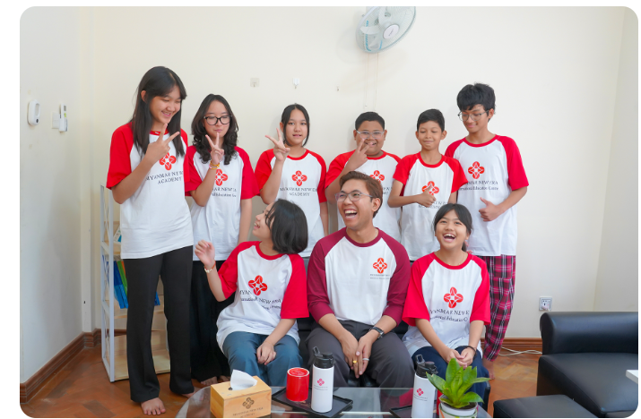 | Chinese Language Program  Chinese Language Program helps learners study Chinese step by step, from foundation pronunciation and basic communication to structured Hanyu and HSK exam preparation.  Contact us
Program Overview: This programme is designed for learners who want to build practical Chinese language ability and prepare for recognised pathways such as HSK and Kaoshi. Students can begin from the basic level, continue through Hanyu stages, and progress toward higher-level exam readiness in a structured classroom setting.
Who Should Join: Students who want to start learning Chinese, improve progressively through Hanyu levels, or prepare for HSK / Kaoshi examinations with guided support.
Levels:
Basic Level Pinyin + Youer Hanyu
Hanyu Level 1 | 2 | 3 | 4 | 5 | 6 | 7 | 8 | 9 | 10 | 11 | 12
HSK HSK 1, HSK 2, HSK 3, HSK 4, HSK 5

Program Details
Course Period :3 March 2026 - 31 May 2026
Availability : Weekday & Weekend Classes

Contact us

